

**KFUPM Soccer Tournament Database System (KSTDS)**

**Phase 3**

|  |  |
| --- | --- |
| **Team 31** | |
| **Name** | **KFUPM ID** |
| **Abdullah AlSabban** | **201756030** |
| **Osama Bujwaied** | **201661700** |
| **Naif Seaidan** | **201651680** |

**For:**

**Dr. Salahadin Mohammed**

**ICS324**

Phase 1

Requirements

**Tournament**

* Name
* Number
* Starts and ends at predefined dates

**Player**

* Kfupm_id
* Team number
* Name
* Date of birth
* Type (student, faculty, or staff)
* Email address
* One or more telephone numbers
* Department

A player can only be in one team in a tournament, but he can be in a different team in another tournament.

**Team**

* Name
* Number
* Address
* Contact numbers
* Website
* Email address
* Main coach
* Manager
* Number of players

**Match**

* Team 1
* Team 2
* Date
* Time
* Field decided before the start of the first match of the tournament
* The referees
* Team leaders of each match

The referees and the team leaders of each match are decided before the first match of the tournament.

**Goals scored by each team in a (match)**

* Team 1
* Team 2
* match
* Time
* Scored goal number

**Red and the yellow cards given to each player at a (tournament) ()**

* Player (KFUPM_ID)
* tournament
* Red card n
* Yellow cards n

(i.e. They will not apply across tournaments):

**Field**

* Name
* Number
* Description
* Status (active, inactive)

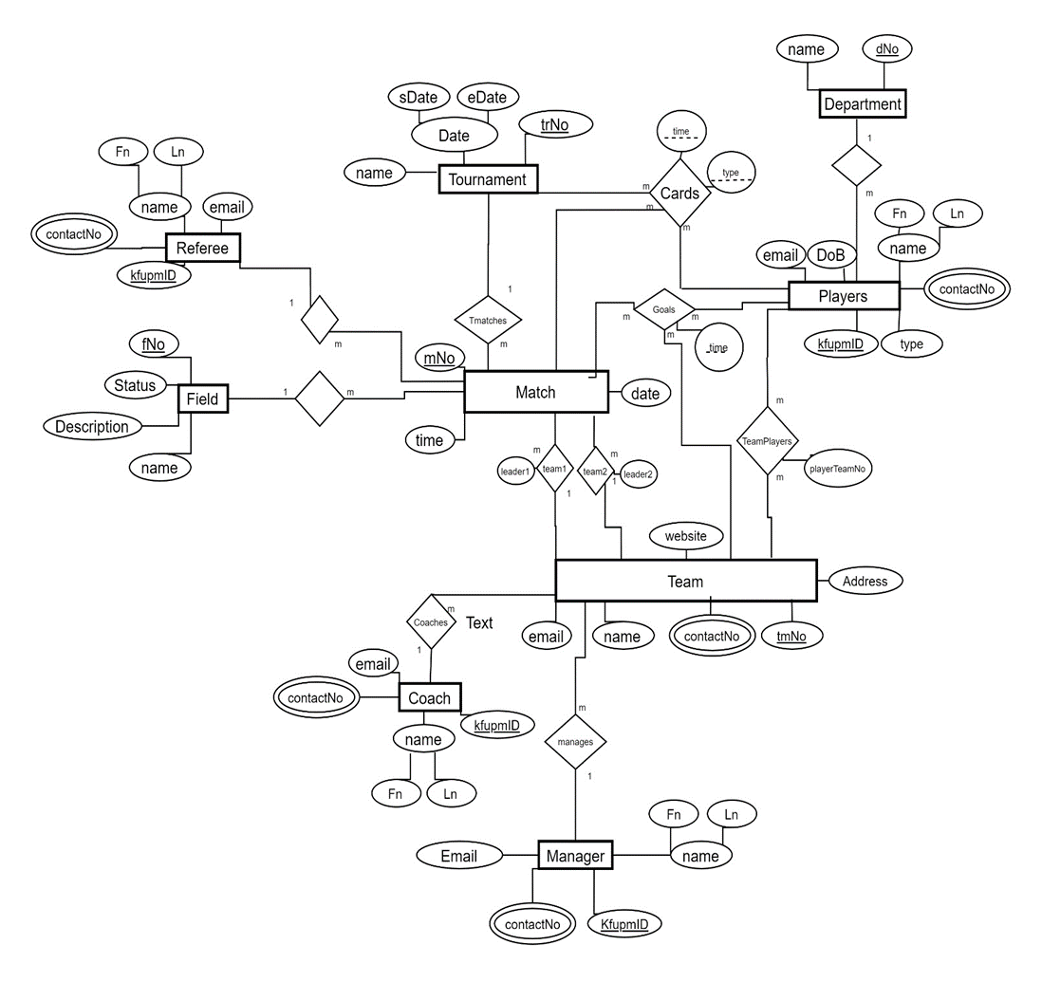Conceptual Design

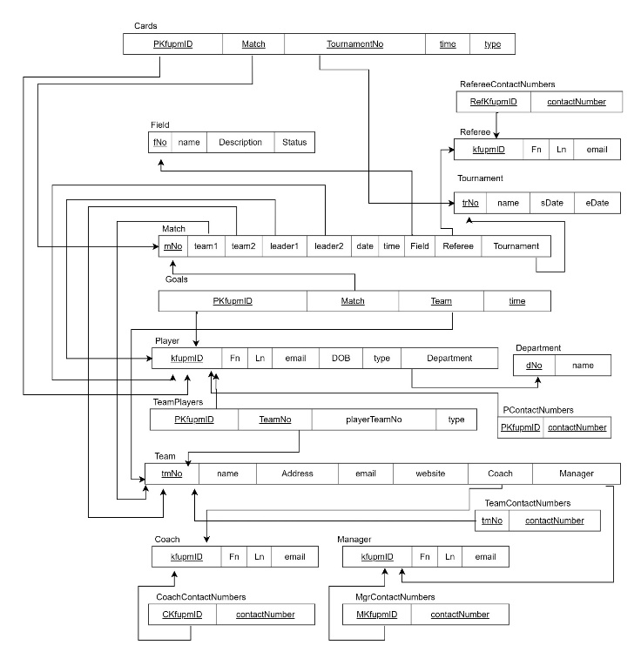Logical design

Phase 2

SQL statements for tables creation and insertion

CREATE TABLE IF NOT EXISTS `Tournament` (

`TorID` int(10) unsigned NOT NULL,

`Name` varchar(20) NOT NULL,

`Startdate` DATE NOT NULL,

`Enddate` DATE NOT NULL,

PRIMARY KEY (`TorID`)

) DEFAULT CHARSET=utf8;

INSERT INTO `Tournament` (`TorID`,`Name`,`Startdate`,`Enddate`) VALUES

('1234','FOOTBALL',date '2013-10-10',date '2013-10-15'),

('4321','BASKETBALL',date '2013-11-10',date '2013-11-15');

CREATE TABLE IF NOT EXISTS `Team` (

`TeamID` int(10) unsigned NOT NULL,

`Name` varchar(20) NOT NULL,

PRIMARY KEY (`TeamID`)

) DEFAULT CHARSET=utf8;

INSERT INTO `Team` (`TeamID`,`Name`) VALUES

('1','TEAM1'),

('2','TEAM2');

CREATE TABLE IF NOT EXISTS `Field` (

`FieldID` int(10) unsigned NOT NULL,

`Name` varchar(20) NOT NULL,

`Description` varchar(200),

PRIMARY KEY (`FieldID`)

) DEFAULT CHARSET=utf8;

INSERT INTO `Field` VALUES

('1','Field1',NULL),

('2','Field2',NULL),

('3','Field3',NULL),

('4','Field4',NULL);

CREATE TABLE IF NOT EXISTS `Match` (

`MatchID` int(10) unsigned NOT NULL,

`Team1ID` int(10) unsigned NOT NULL,

`Team2ID` int(10) unsigned NOT NULL,

`FieldID` int(10) unsigned NOT NULL,

`Date` DATE NOT NULL,

`Time` TIME NOT NULL,

`Team1Goals` int(2) unsigned NOT NULL,

`Team2Goals` int(2) unsigned NOT NULL,

`Comments` varchar(200),

PRIMARY KEY (`MatchID`),

FOREIGN KEY (Team1ID) REFERENCES Team(TeamID),

FOREIGN KEY (Team2ID) REFERENCES Team(TeamID),

FOREIGN KEY (FieldID) REFERENCES Field(FieldID)

) DEFAULT CHARSET=utf8;

INSERT INTO `Match` VALUES

('1','1','2','1',date '2013-10-10',time '6:30:00','5','3',NULL),

('2','2','1','1',date '2013-10-11',time '6:30:00','2','0',NULL);

CREATE TABLE IF NOT EXISTS `Category` (

`CatID` int(10) unsigned NOT NULL,

`Name` varchar(15) NOT NULL,

`Desc` varchar(100),

PRIMARY KEY (`CatID`)

) DEFAULT CHARSET=utf8;

INSERT INTO `Category` VALUES

('1','ACTOR',NULL),

('2','TorActor',NULL),

('3','MatchActor',NULL),

('4','Event',NULL);

CREATE TABLE IF NOT EXISTS `Type` (

`TypeID` int(10) unsigned NOT NULL,

`CatID` int(10) unsigned NOT NULL,

`Name` varchar(15) NOT NULL,

`Desc` varchar(100),

PRIMARY KEY (`TypeID`),

Foreign KEY (CatID) REFERENCES Category(CatID)

) DEFAULT CHARSET=utf8;

INSERT INTO `Type` VALUES

('1','1','Student',NULL),

('2','1','Faculty',NULL),

('3','1','Staff',NULL),

('4','2','Player',NULL);

CREATE TABLE IF NOT EXISTS `Department` (

`DeptID` int(10) unsigned NOT NULL,

`Code` varchar(4) NOT NULL,

`Name` varchar(200) NOT NULL,

PRIMARY KEY (`DeptID`)

) DEFAULT CHARSET=utf8;

INSERT INTO `Department` VALUES

('1','ICS','Information and Computer Science'),

('2','SWE','Software Engineering');

CREATE TABLE IF NOT EXISTS `Actor` (

`KFUPMID` int(10) unsigned NOT NULL,

`Fname` varchar(10) NOT NULL,

`Lname` varchar(10) NOT NULL,

`DeptID` int(10) unsigned NOT NULL,

`TypeID` int(10) unsigned NOT NULL,

PRIMARY KEY (`KFUPMID`),

FOREIGN KEY (DeptID) REFERENCES Department(DeptID),

FOREIGN KEY (TypeID) REFERENCES Type(TypeID)

) DEFAULT CHARSET=utf8;

INSERT INTO `Actor` VALUES

('1','Naif','Khaleel','1','1'),

('2','Khaled','Abdullah','2','2');

CREATE TABLE IF NOT EXISTS `TorActor` (

`TorID` int(10) unsigned NOT NULL,

`KFUPMID` int(10) unsigned NOT NULL,

`TeamID` int(10) unsigned NOT NULL,

`TypeID` int(10) unsigned NOT NULL,

FOREIGN KEY (TorID) REFERENCES Tournament(TorID),

FOREIGN KEY (KFUPMID) REFERENCES Actor(KFUPMID),

FOREIGN KEY (TeamID) REFERENCES Team(TeamID),

FOREIGN KEY (TypeID) REFERENCES Type(TypeID)

) DEFAULT CHARSET=utf8;

INSERT INTO `TorActor` VALUES

('1234','1','1','1'),

('4321','2','2','2');

CREATE TABLE IF NOT EXISTS `MatchActor` (

`MatchID` int(10) unsigned NOT NULL,

`KFUPMID` int(10) unsigned NOT NULL,

`TypeID` int(10) unsigned NOT NULL,

FOREIGN KEY (MatchID) REFERENCES `Match`(MatchID),

FOREIGN KEY (KFUPMID) REFERENCES Actor(KFUPMID),

FOREIGN KEY (TypeID) REFERENCES Type(TypeID)

) DEFAULT CHARSET=utf8;

INSERT INTO `MatchActor` VALUES

('1','1','1'),

('2','2','2');

CREATE TABLE IF NOT EXISTS `Event` (

`MatchID` int(10) unsigned NOT NULL,

`KFUPMID` int(10) unsigned NOT NULL,

`TypeID` int(10) unsigned NOT NULL,

`Time` time NOT NULL,

FOREIGN KEY (MatchID) REFERENCES `Match`(MatchID),

FOREIGN KEY (KFUPMID) REFERENCES Actor(KFUPMID),

FOREIGN KEY (TypeID) REFERENCES Type(TypeID)

) DEFAULT CHARSET=utf8;

INSERT INTO `Event` VALUES

('1','1','1',time '6:30:0'),

('2','2','1',time '8:30:0');

CREATE TABLE IF NOT EXISTS `ContactType` (

`ConTypeID` int(10) unsigned NOT NULL,

`Name` varchar(15) NOT NULL,

`Desc` varchar(150),

PRIMARY KEY (`ConTypeID`)

) DEFAULT CHARSET=utf8;

INSERT INTO `ContactType` VALUES

('1','Mobile',null),

('2','Land line',null),

('3','Email',null),

('4','Addres',null);

CREATE TABLE IF NOT EXISTS `Contact` (

`KFUPMID` int(10) unsigned NOT NULL,

`ConTypeID` int(10) unsigned NOT NULL,

`Value` varchar(25) NOT NULL,

FOREIGN KEY (KFUPMID) REFERENCES Actor(KFUPMID),

FOREIGN KEY (ConTypeID) REFERENCES ContactType(ConTypeID)

) DEFAULT CHARSET=utf8;

INSERT INTO `Contact` VALUES

('1','1','050-0371715'),

('2','3','adam@kfupm.edu.sa');

Statements to show the tables :

SELECT * from `Tournament`;

SELECT * from `Team`;

SELECT * from `Field`;

SELECT * from `Match`;

SELECT * from `Category`;

SELECT * from `Type`;

SELECT * from `Department`;

SELECT * from `Actor`;

SELECT * from `TorActor`;

SELECT * from `MatchActor`;

SELECT * from `Event`;

SELECT * from `ContactType`;

SELECT * from `Contact`;

This was made by using the following website :

<http://sqlfiddle.com/>

Phase 3

Requirements

* **Tournament**
  + **TorID**
  + **Name**
  + **Startdate**
  + **Enddate**
* **Match**
  + **MatchID**
  + **Team1ID**
  + **Team2ID**
  + **FiledID**
  + **Date**
  + **Time**
  + **Team1Goals**
  + **Team2Goals**
  + **Comments**
* **Team**
  + **TeamID**
  + **Name**
* **Actor**
  + **KFUPMID**
  + **Fname**
  + **Lname**
  + **DeptID**
  + **TypeID**
* **TorActor**
  + **TorID**
  + **KFUPMID**
  + **TeamID**
  + **TypeID**
* **MatchActor**
  + **MatchID**
  + **KFUPMID**
  + **TypeID**
* **Category**
  + **CatID**
  + **Name**
  + **Desc**
* **Type**
  + **TYpeID**
  + **CatID**
  + **Name**
  + **Desc**
* **Field**
  + **FieldID**
  + **Name**
  + **Desc**
* **Department**
  + **DeptID**
  + **Code**
  + **Name**
* **Event**
  + **MatchID**
  + **KFUPMID**
  + **TypeID**
  + **Time**
* **ContactType**
  + **ConTypeID**
  + **Name**
  + **Desc**
* **Contact**
  + **KFUPMID**
  + **ConTypeID**
  + **Value**

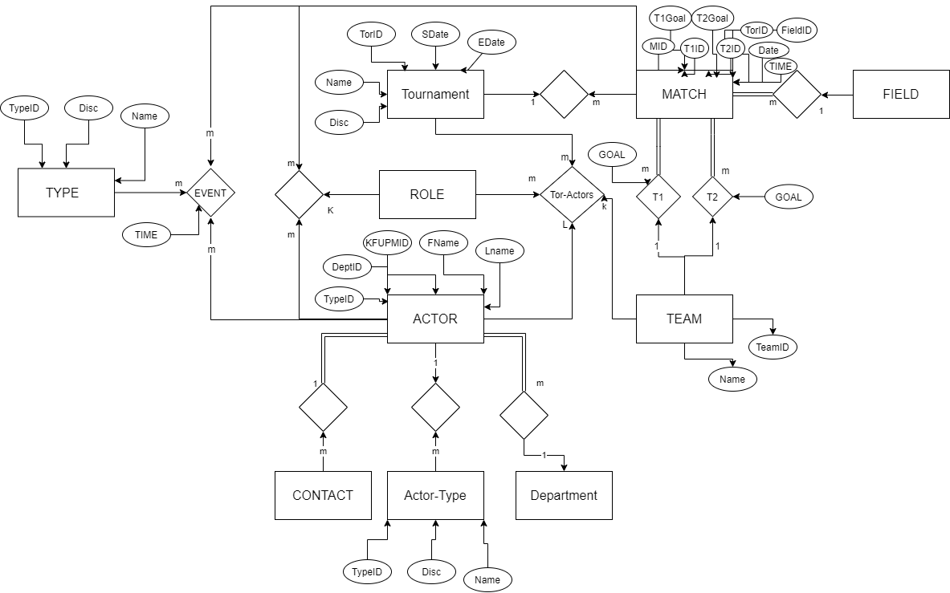Conceptual Design

Logical design

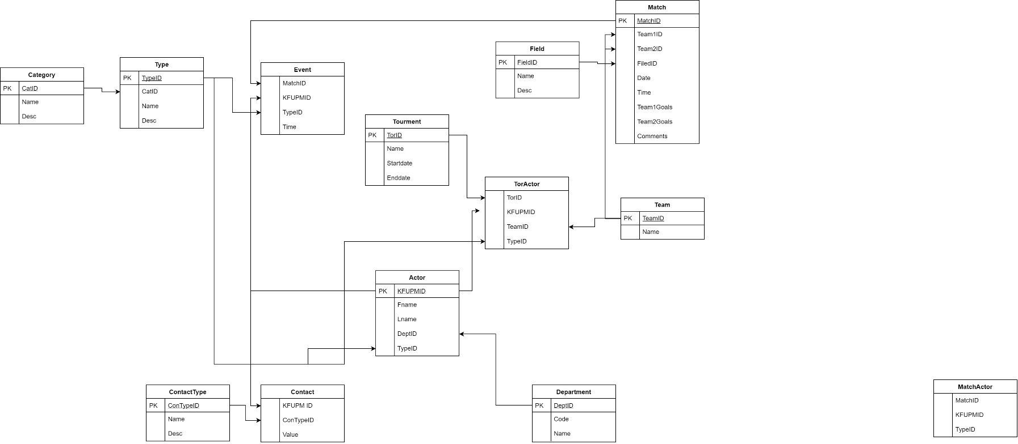

SQL statements for tables creation and insertion

CREATE TABLE IF NOT EXISTS `Tournament` (

`TorID` int(10) unsigned NOT NULL,

`Name` varchar(20) NOT NULL,

`Startdate` DATE NOT NULL,

`Enddate` DATE NOT NULL,

PRIMARY KEY (`TorID`)

) DEFAULT CHARSET=utf8;

INSERT INTO `Tournament` (`TorID`,`Name`,`Startdate`,`Enddate`) VALUES

('1234','FOOTBALL',date '2013-10-10',date '2013-10-15'),

('4321','BASKETBALL',date '2013-11-10',date '2013-11-15');

CREATE TABLE IF NOT EXISTS `Team` (

`TeamID` int(10) unsigned NOT NULL,

`Name` varchar(20) NOT NULL,

PRIMARY KEY (`TeamID`)

) DEFAULT CHARSET=utf8;

INSERT INTO `Team` (`TeamID`,`Name`) VALUES

('1','TEAM1'),

('2','TEAM2'),

('3','TEAM3'),

('4','TEAM4');

CREATE TABLE IF NOT EXISTS `Field` (

`FieldID` int(10) unsigned NOT NULL,

`Name` varchar(20) NOT NULL,

`Description` varchar(200),

PRIMARY KEY (`FieldID`)

) DEFAULT CHARSET=utf8;

INSERT INTO `Field` VALUES

('1','Field1',NULL),

('2','Field2',NULL),

('3','Field3',NULL),

('4','Field4',NULL);

CREATE TABLE IF NOT EXISTS `Match` (

`MatchID` int(10) unsigned NOT NULL,

`Team1ID` int(10) unsigned NOT NULL,

`Team2ID` int(10) unsigned NOT NULL,

`FieldID` int(10) unsigned NOT NULL,

`Date` DATE NOT NULL,

`Time` TIME NOT NULL,

`Team1Goals` int(2) unsigned NOT NULL,

`Team2Goals` int(2) unsigned NOT NULL,

`Comments` varchar(200),

PRIMARY KEY (`MatchID`),

FOREIGN KEY (Team1ID) REFERENCES Team(TeamID),

FOREIGN KEY (Team2ID) REFERENCES Team(TeamID),

FOREIGN KEY (FieldID) REFERENCES Field(FieldID)

) DEFAULT CHARSET=utf8;

INSERT INTO `Match` VALUES

('1','1','2','1',date '2013-10-10',time '6:30:00','5','3',NULL),

('2','3','4','4',date '2013-10-11',time '6:30:00','2','0',NULL);

CREATE TABLE IF NOT EXISTS `Category` (

`CatID` int(10) unsigned NOT NULL,

`Name` varchar(15) NOT NULL,

`Desc` varchar(100),

PRIMARY KEY (`CatID`)

) DEFAULT CHARSET=utf8;

INSERT INTO `Category` VALUES

('1','ACTOR',NULL),

('2','TorActor',NULL),

('3','MatchActor',NULL),

('4','Event',NULL);

CREATE TABLE IF NOT EXISTS `Type` (

`TypeID` int(10) unsigned NOT NULL,

`CatID` int(10) unsigned NOT NULL,

`Name` varchar(15) NOT NULL,

`Desc` varchar(100),

PRIMARY KEY (`TypeID`),

Foreign KEY (CatID) REFERENCES Category(CatID)

) DEFAULT CHARSET=utf8;

INSERT INTO `Type` VALUES

('1','1','Student',NULL),

('2','1','Faculty',NULL),

('3','1','Staff',NULL),

('4','2','Player',NULL),

('5','2','Referee',NULL),

('6','2','Manager',NULL),

('7','2','Coach',NULL),

('8','3','Player',NULL),

('9','3','Captain',NULL),

('10','3','Goal keeper',NULL),

('11','3','Main Refree',NULL),

('12','3','Asst. Refree',NULL),

('13','4','Yellow Card',NULL),

('14','4','Red Card',NULL),

('15','4','Normal Goal',NULL),

('16','4','Penalty Goal','Goal by penalty kick'),

('17','4','Self Goal','Goal on own team');

CREATE TABLE IF NOT EXISTS `Department` (

`DeptID` int(10) unsigned NOT NULL,

`Code` varchar(4) NOT NULL,

`Name` varchar(200) NOT NULL,

PRIMARY KEY (`DeptID`)

) DEFAULT CHARSET=utf8;

INSERT INTO `Department` VALUES

('1','ICS','Information and Computer Science'),

('2','SWE','Software Engineering');

CREATE TABLE IF NOT EXISTS `Actor` (

`KFUPMID` int(10) unsigned NOT NULL,

`Fname` varchar(10) NOT NULL,

`Lname` varchar(10) NOT NULL,

`DeptID` int(10) unsigned NOT NULL,

`TypeID` int(10) unsigned NOT NULL,

PRIMARY KEY (`KFUPMID`),

FOREIGN KEY (DeptID) REFERENCES Department(DeptID),

FOREIGN KEY (TypeID) REFERENCES Type(TypeID)

) DEFAULT CHARSET=utf8;

INSERT INTO `Actor` VALUES

('1','Naif','Khaleel','1','1'),

('2','Khaled','Abdullah','2','2'),

('3','Naiff','K','1','1'),

('4','Khaledd','A','2','2');

CREATE TABLE IF NOT EXISTS `TorActor` (

`TorID` int(10) unsigned NOT NULL,

`KFUPMID` int(10) unsigned NOT NULL,

`TeamID` int(10) unsigned NOT NULL,

`TypeID` int(10) unsigned NOT NULL,

FOREIGN KEY (TorID) REFERENCES Tournament(TorID),

FOREIGN KEY (KFUPMID) REFERENCES Actor(KFUPMID),

FOREIGN KEY (TeamID) REFERENCES Team(TeamID),

FOREIGN KEY (TypeID) REFERENCES Type(TypeID)

) DEFAULT CHARSET=utf8;

INSERT INTO `TorActor` VALUES

('1234','1','1','1'),

('1234','2','1','1'),

('1234','3','1','1'),

('1234','4','2','1'),

('4321','2','2','2');

CREATE TABLE IF NOT EXISTS `MatchActor` (

`MatchID` int(10) unsigned NOT NULL,

`KFUPMID` int(10) unsigned NOT NULL,

`TypeID` int(10) unsigned NOT NULL,

FOREIGN KEY (MatchID) REFERENCES `Match`(MatchID),

FOREIGN KEY (KFUPMID) REFERENCES Actor(KFUPMID),

FOREIGN KEY (TypeID) REFERENCES Type(TypeID)

) DEFAULT CHARSET=utf8;

INSERT INTO `MatchActor` VALUES

('1','1','1'),

('1','2','2'),

('1','4','1'),

('1','3','2');

CREATE TABLE IF NOT EXISTS `Event` (

`MatchID` int(10) unsigned NOT NULL,

`KFUPMID` int(10) unsigned NOT NULL,

`TypeID` int(10) unsigned NOT NULL,

`Time` time NOT NULL,

FOREIGN KEY (MatchID) REFERENCES `Match`(MatchID),

FOREIGN KEY (KFUPMID) REFERENCES Actor(KFUPMID),

FOREIGN KEY (TypeID) REFERENCES Type(TypeID)

) DEFAULT CHARSET=utf8;

INSERT INTO `Event` VALUES

('1','3','12',time '6:30:0'),

('2','2','11',time '8:30:0'),

('2','1','15',time '6:30:0'),

('2','4','17',time '8:30:0'),

('2','1','16',time '6:30:0'),

('2','4','15',time '8:30:0'),

('2','1','17',time '6:30:0'),

('2','4','16',time '8:30:0');

CREATE TABLE IF NOT EXISTS `ContactType` (

`ConTypeID` int(10) unsigned NOT NULL,

`Name` varchar(15) NOT NULL,

`Desc` varchar(150),

PRIMARY KEY (`ConTypeID`)

) DEFAULT CHARSET=utf8;

INSERT INTO `ContactType` VALUES

('1','Mobile',null),

('2','Land line',null),

('3','Email',null),

('4','Addres',null);

CREATE TABLE IF NOT EXISTS `Contact` (

`KFUPMID` int(10) unsigned NOT NULL,

`ConTypeID` int(10) unsigned NOT NULL,

`Value` varchar(25) NOT NULL,

FOREIGN KEY (KFUPMID) REFERENCES Actor(KFUPMID),

FOREIGN KEY (ConTypeID) REFERENCES ContactType(ConTypeID)

) DEFAULT CHARSET=utf8;

INSERT INTO `Contact` VALUES

('1','1','050-0371715'),

('2','3','adam@kfupm.edu.sa');

This was made by using the following website:

<http://sqlfiddle.com/>

Implementation

Forms

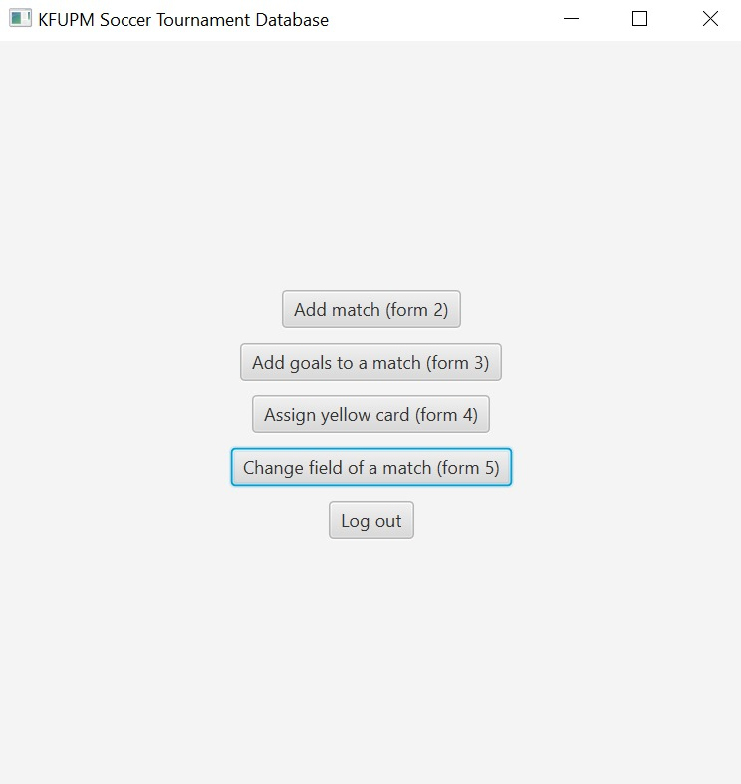

* Login & logout

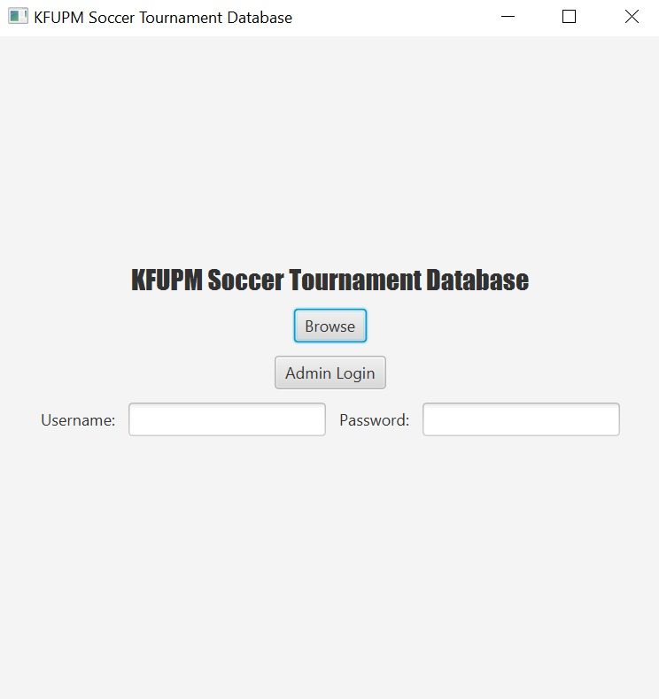

* Add a new match

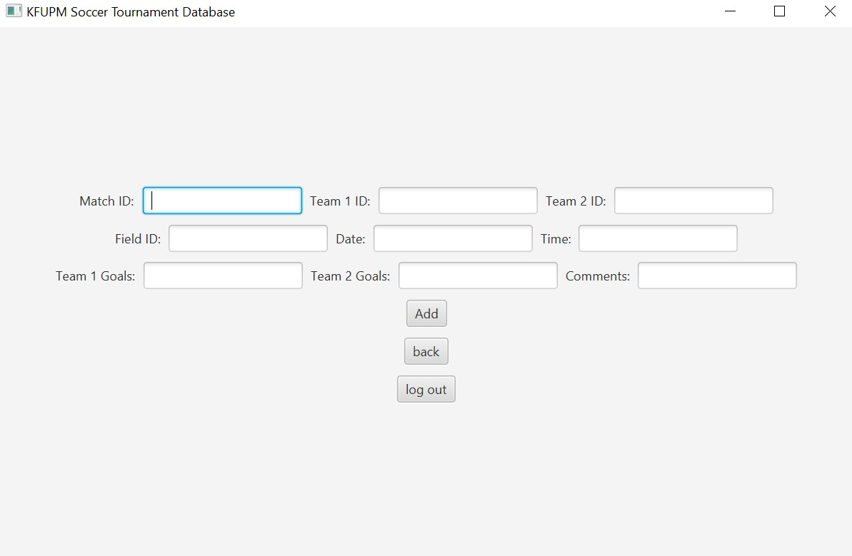

* Add goals of each team in a match

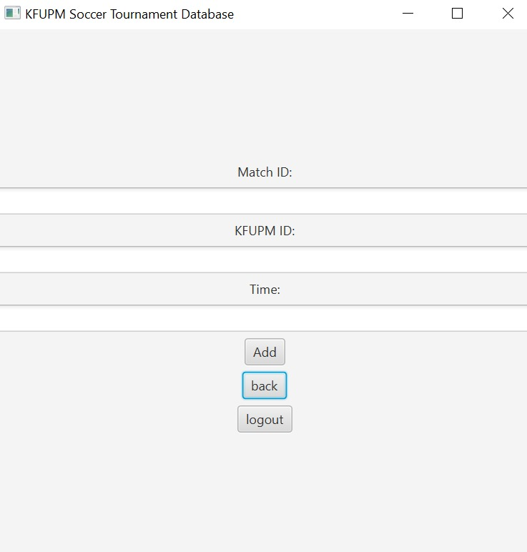

Reports

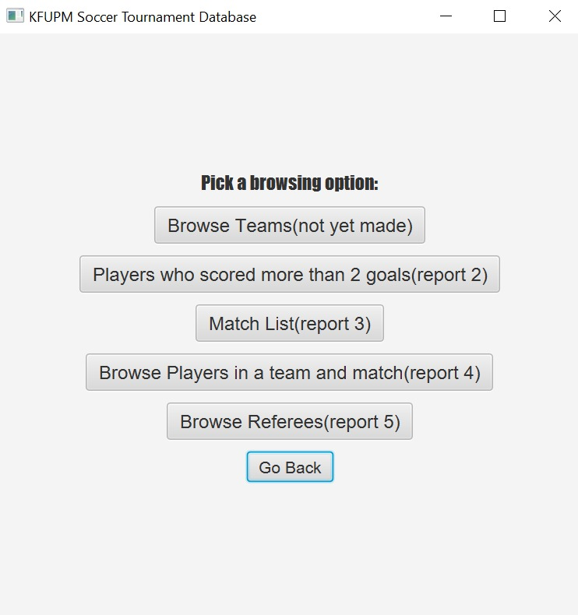

* List each player who scored more than two goals.

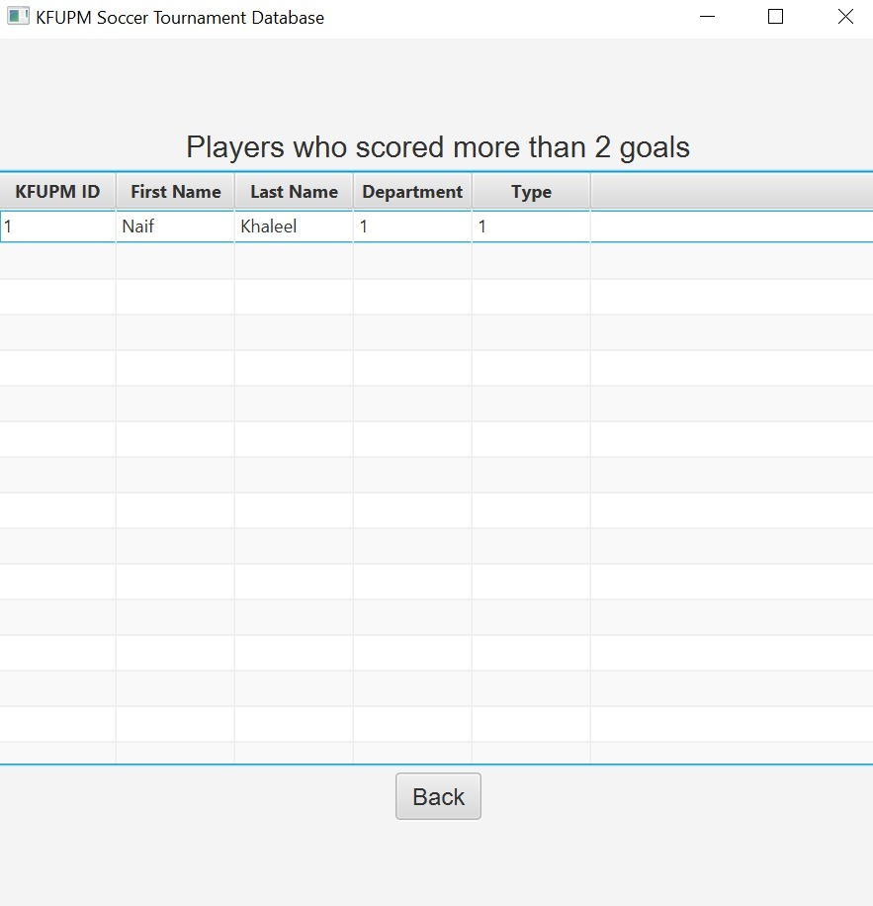

* List the date, the filed, and the teams of each match.

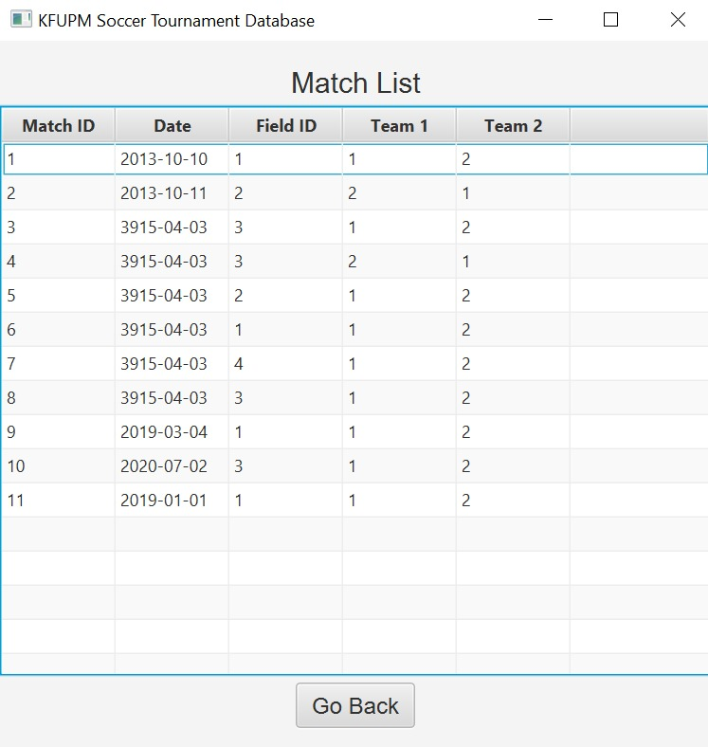

Tools and Resources Used

* Draw.io website
* SQL Fiddle website
* JavaFX
* MySQL application
* IntelliJ IDE

Problem Faced

* SQL fiddle website was down for an unknown reason.
* Installing MySQL. Some of the MySQL subprograms would not install.
* Connecting JavaFX to MySQL would not work in the eclipse IDE, which lead us to transfer to Intellij.
* Implementing user interface in Intellij

Things Learned from Project

* Implementing Informative User interface
* Connecting JavaFX to MySQL

Percentage Operation Completion Table

|  |  |
| --- | --- |
| **Operation** | **Percent Completion** |
| Login & logout | 100 |
| Add a new match | 100 |
| Add goals of each team in a match | 100 |
| Assign a player a yellow card | 100 |
| Change the field of a match | 100 |
| List, the goals scored, goals received, points, and rank of each team. | 50 |
| List each player who scored more than two goals. | 100 |
| List the date, the filed, and the teams of each match | 100 |
| List the players of a given team who played in a given match | 100 |
| List the matches refereed by a given referee | 100 |

Task Done by Each Group member

|  |  |
| --- | --- |
| **Group member** | **Task** |
| Abdullah AlSabban | User Interface |
| Osama Bujwaied | Forms & Reports Coding |
| Naif Seaidan | Forms & Reports Coding |

Suggestions to improve ICS324

|  |
| --- |
| Improve slides for the course |
| Add old exam |
| Add more resources that can be used to make phase 3 |